**Vid 6.1 cont**

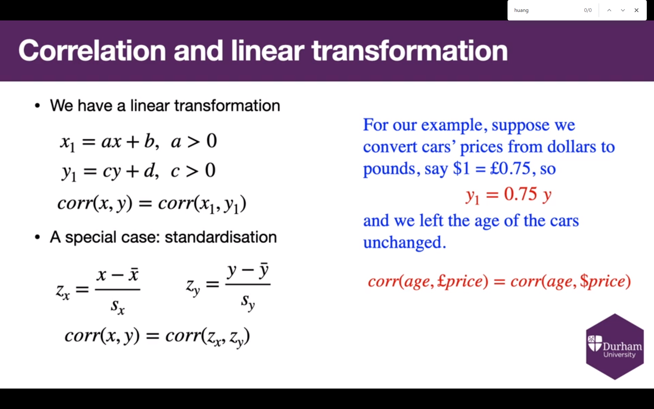

(For workshop: do a scaling example to show correlation is invariant)

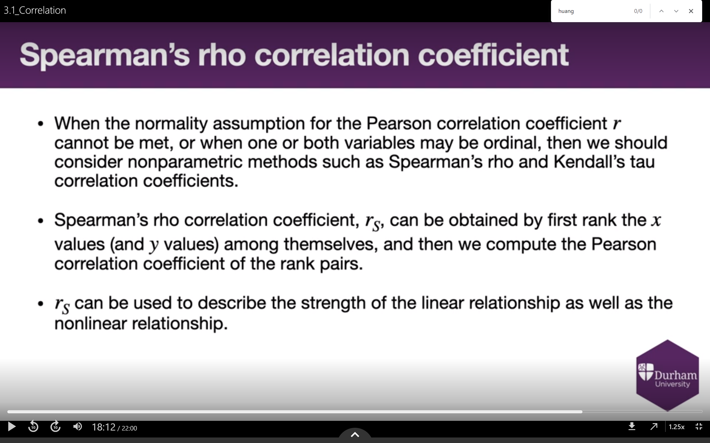

(Spearman also works with normally dsistributed data, so a useful general test)

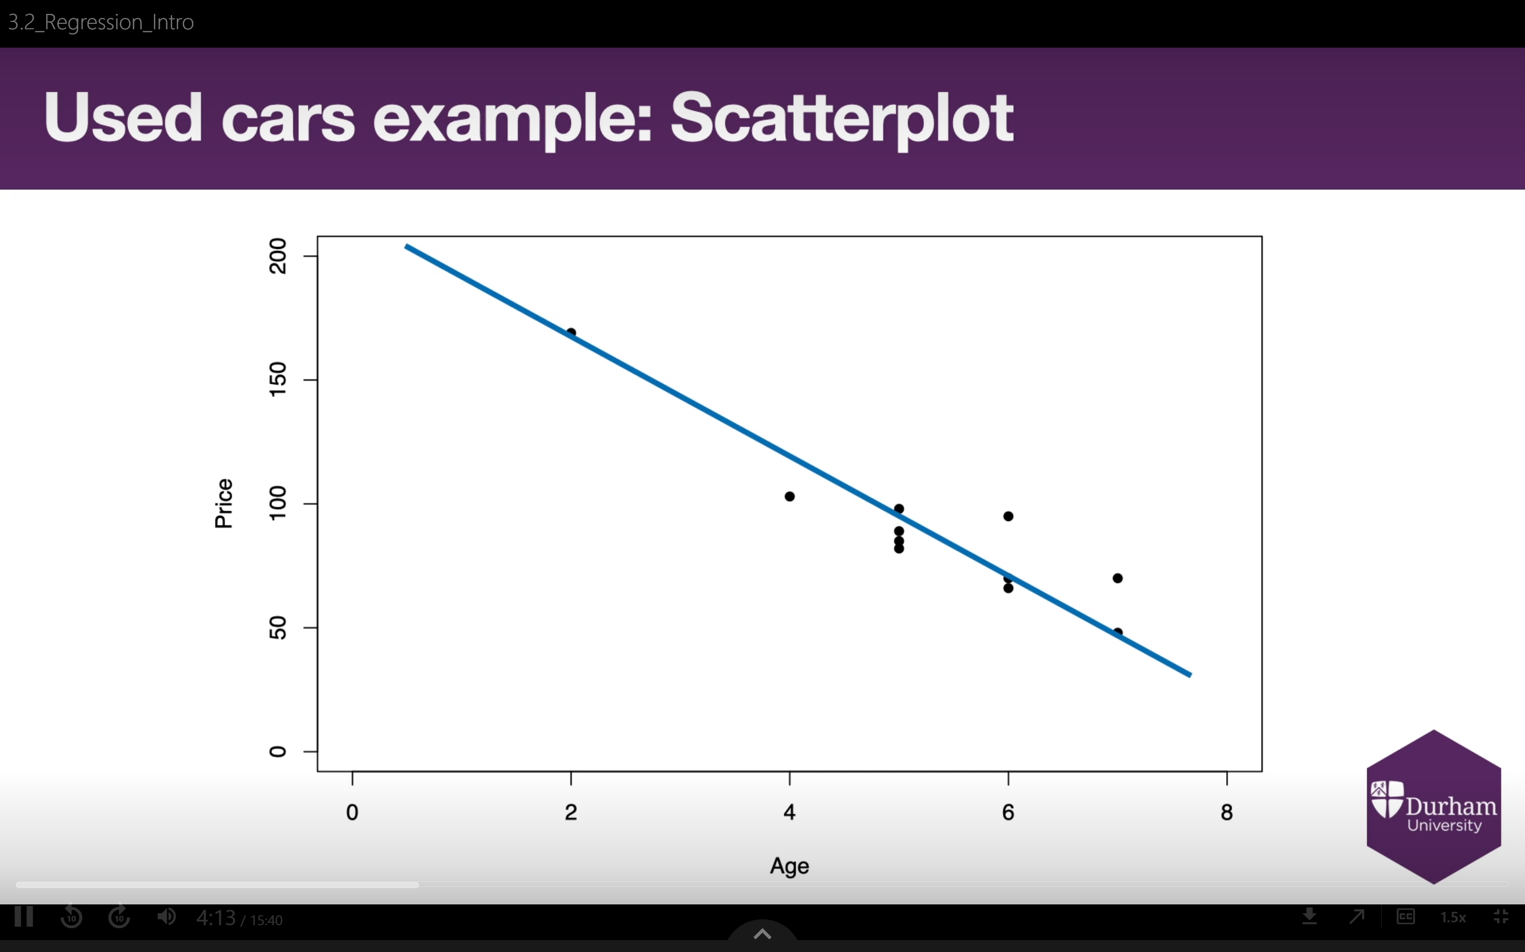

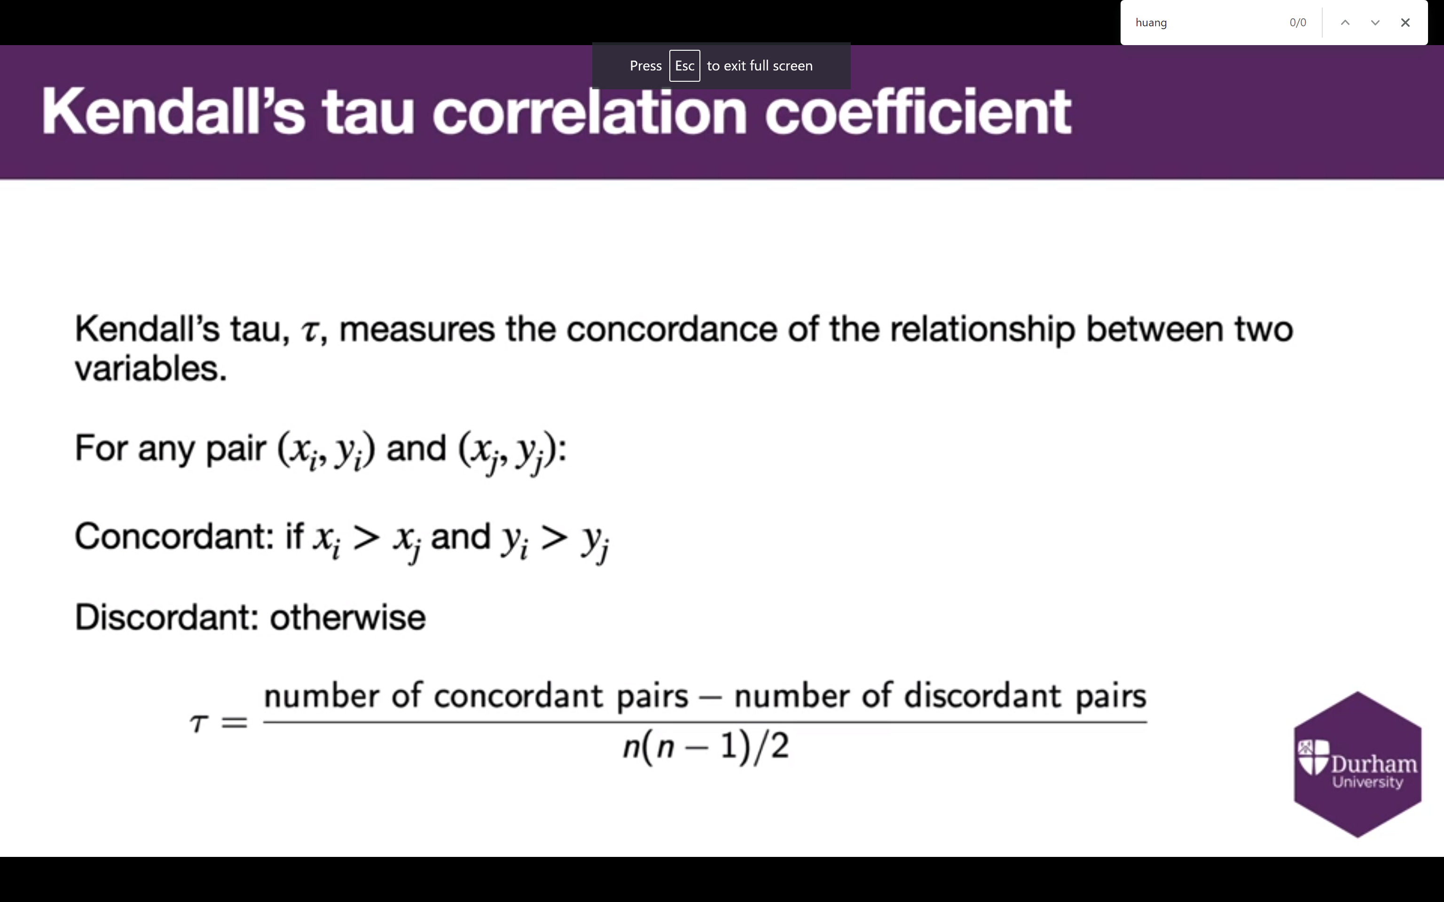

(Spearman vs Pearson vs Kendalls)

**6.2 – Introduction To Regression**

Welcome

In our last video, we talked about various ways we can measure correlation – how close two variables are to having a perfect linear relationship. One of the ideas we covered was that there are various functions that might describe the relationship between two random variables. Why are we so focussed on straight lines?

The answer to that question is going to take us two weeks to fully consider, but we’re going to make a start in this video. Using straight lines allows us to make use of a technique known as linear regression, which is an extremely powerful and commonly used type of regression method. That, though, jut immediately raises the question of what I mean by “regression” in the first place.

Our first learning objective for this video, then, is to go through an informal definition of what regression actually is. The short version is that it’s a process by which we input values we have to get a prediction for some value we don’t have, but there’s much more to be said. Our second learning objective is to consider those ideas that specifically describe **linear** regression. One important aspect to linear regression is the idea that there exists some kind of “true” linear relationship between two random variables, and that all we can do as statisticians is try to approximate that relationship. Seeing how to do that most effectively will be our third and final learning objective.

(Slide )

Let’s start off with an example of a situation we might want to use regression for. Let’s say you want to buy a used bike to cycle around Durham. There are a lot of different possible options you could go for, through various shops or websites. You want to make sure you get a fair price for the bike you buy. How can you come up with a predicted price for a used bike? You’d want to take into account various different pieces of information – how old the bike is, and what the make was. Maybe the price when the bike was new is relevant, or how many previous owners the bike has. What you want is to be able to gather whatever information you think is relevant for a given bike that’s on sale, and use it to predict a price for such a bike. That way, you have at least some idea of how much of a bargain/rip-off any given price is for any given bike.

This, fundamentally, is regression – using values we have to predict a numerical value we don’t. Each of the values we have is a realisation from a variable. We call those variables “predictor variables”, because they’re what allow us to make predictions. We also sometimes call them covariables, or independent variables. The value we are trying to predict is also a realisation of a variable, what we call the **response** variable, because it takes a value in response to the predictor variables. We also call this variable the **dependent variable**, to contrast with the **independent** variables. The idea here is that the response variable is literally dependent upon the predictor variables, which are (we hope) independent of each other. In this module, we will assume there can be multiple independent variables, but only one dependent variable. That latter condition can be relaxed, but we’re not going to.

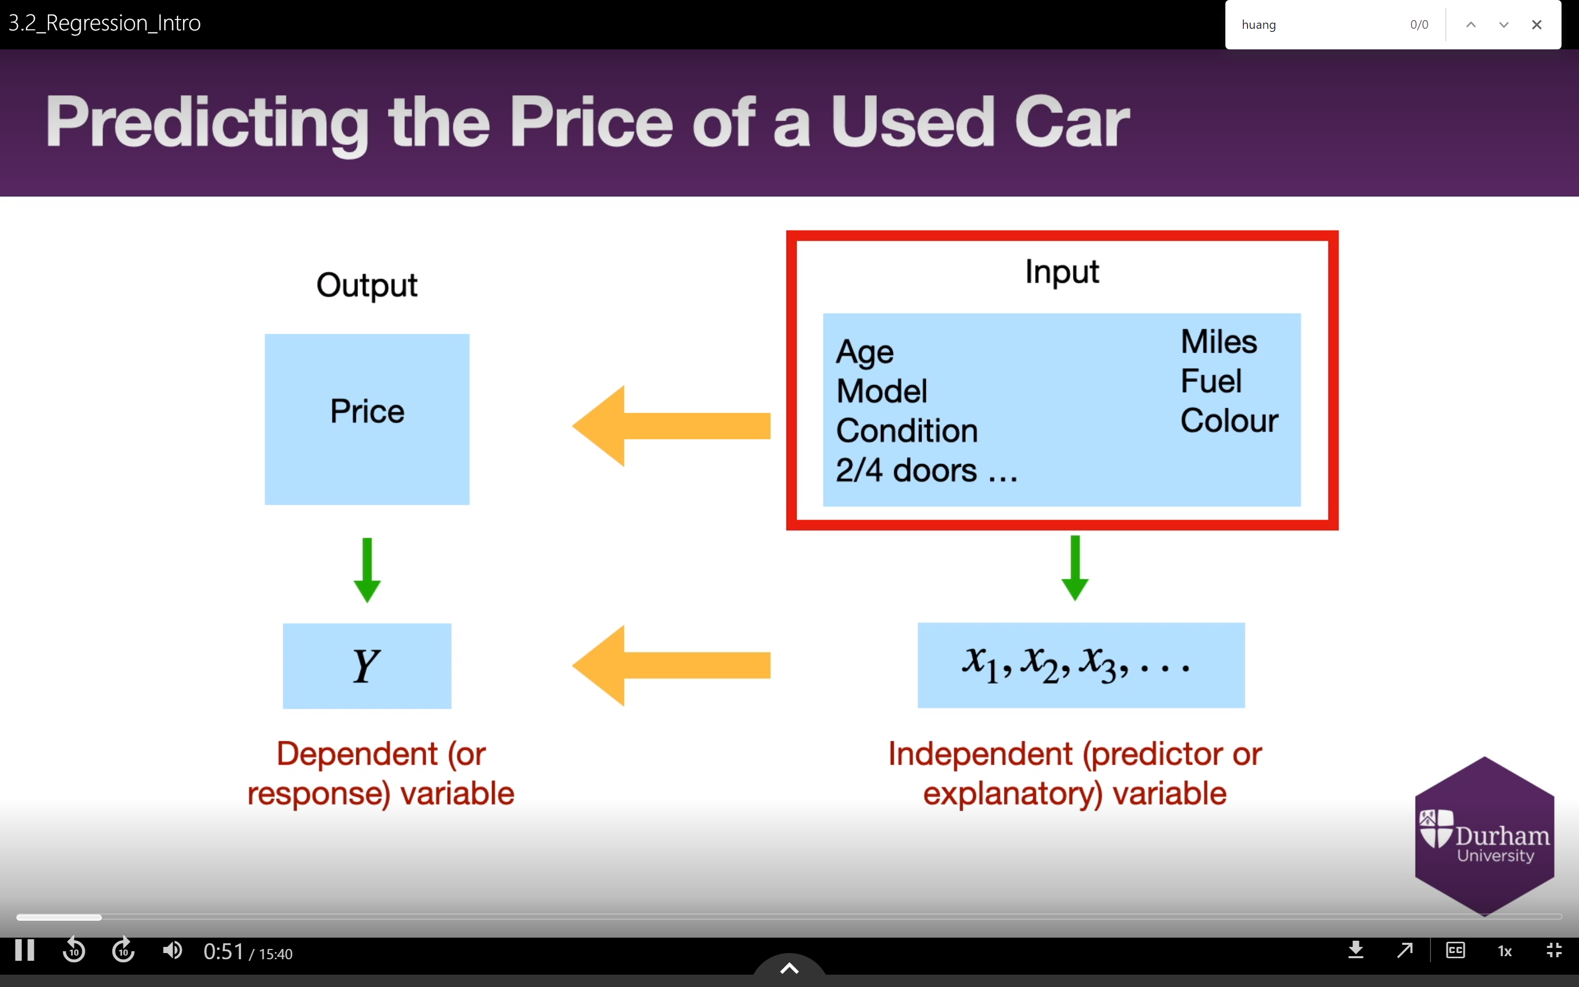

Another way to think of this approach, which is equivalent, is that we have a list of inputs – age, number of previous owners, etc. – which we put into a **regression function** to get a value for an **output**, in this case price.

The key word in what I just is **function**. For regression to work, we need to know what function we’re using to turn inputs into outputs. One option is for our function to be **linear**, which is where linear regression comes in.

(Slide)

We’re going to start talking about linear regression with a specific case; what we call **simple linear regression**. Now, whether you end up thinking this approach actually **is** simple is an open question. The reason the approach we’re about to look at is labelled as “simple” is because it uses just one predictor variable, so it’s the most simple situation that we can apply regression to.

And really, I think it’s fair to call this approach simple, when we consider that It’s nothing more than a refinement of a technique many if not all you learned at school. Did you ever do an experiment in your class to compare, say, height against foot length? I remember doing this when I was a child. We measured the height and foot length of each pupil in the class, and displayed the results on a scatter diagram. This had two purposes First, it showed there’s a relationship between height and foot length, and that the relationship looked at least sort of like a straight line. Second, we could **use** that straight line to make predictions.

This is literally all simple linear regression is. Get your data, draw your scatter diagram, draw your line, and make. There are some theoretical ideas linked to this which we’ll consider today, which is where things get trickier, but the **process** of performing linear regression isn’t at all unfamiliar to you.

So why is this material I’m teaching at university, rather than in a secondary school? When we introduce this idea to school children, we generally tell them to draw a line that “looks” right. This can lead to more than one line being drawn, none of which look obviously wrong. If we look at the cars data in R, for instance, and try to draw a line expressing the relationship between speed and stopping distance, there are a number of plausible lines we could draw. It’s clear each of these lines captures something close to a relationship that genuinely seems to exist – to reference Video 6.1, the correlation here is 0.807. But which one does it **best**?

Simple linear regression allows us to answer that question, drawing a line for us that is by some measure “the best”. So how do we draw what we might call “the best line of best fit”?

I’ll answer that in a few minutes, but first; we’ll need a bit more notation. You should already be aware of how we write an equation for a straight line. Commonly, we define a straight line using the equation y = mx + c, where m is the gradient or steepness of the line, and c is what we call the **y-intercept**, the value y takes then the line passes through the y-axis at x=0.

We’ll use the same equation, but with different terms. We will define a straight line using the equation y = b_1 x + b_0. So now beta_1 is the gradient, and beta_0 is the y-intercept. So for a given value of the independent variable – let’s call it x_0, and I’ll explain the subscript in a moment – the corresponding estimate of the dependent variable is b_1x_0 + b_0. We call this estimate y hat subscript 0; remember, we’ve already used the hat symbol to represent estimates before, back in Week 4.

From now on, we’re going to assume that we have n pairs of values in our scatter diagram. We will label each pair as (x_i, y_i), where i can take any value between 1 and n. This is the reason we used x_0 as a possible independent variable value earlier; the zero tells us it isn’t one of the values from the data itself, but some new value we’re imagining. For each point (x_i,y_i) there is an associated value y hat I, which is the value our model predicts for y_i. These won’t be the same, unless the regression line goes right through the point x_i, y_i.

Right. We’re ready to talk about finding the regression line. Finding this line uses something we refer to as the least squares criterion, a fancy name that breaks down into what I hope you’ll think of as a simple idea. When we draw a line of best fit, we won’t draw it through every single point – or at least, if we could do that, we’d have a perfect linear relationship and wouldn’t need regression to begin with.

When we draw a line, then, we get errors -differences between what the line says **“should”** be the value of the response variables, and what the data says that value actually is We can think of these errors as vertical lines between the line of best fit and each point, as shown on screen. We can define the value e subscript i as equalling y_i minus y hat_i – that is, e_i is the difference between what we know the value of y_i is, and what the line we’ve drawn would predict that value to be.

We would like these values to be as small as possible overall. But what does “as small as possible overall” actually mean? Well, we could try adding all the values of e_i, to see how big that value is. The problem with this though is that an e_i value will be positive each time a point lies above the line, and negative each time a point lies below the line. These positive and negative values will then at least partially cancel each other out when you add them all together.

Our fix for this is very simple. Rather than adding together each of the e_i values, we add together the values of all the **squared**  e_i values. Squaring makes every value non-negative, so you don’t need to worry about values working to cancel each other out. We are therefore adding together a sequence of square numbers, and looking for the line that gives us the least value doing so. Hence: least squares criterion.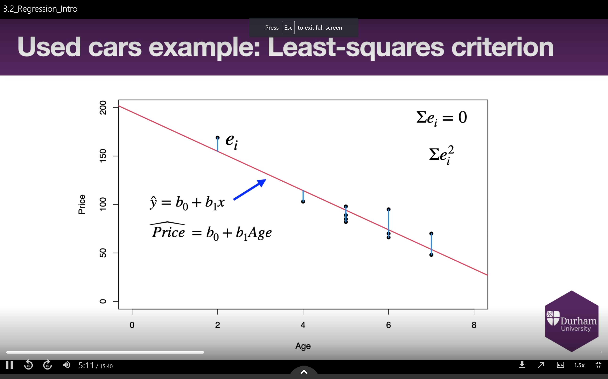

And that’s it. That’s genuinely it, in terms of what a regression line is. It is the line which gives us the minimum possible value of the sum of squared e_i values. Job done!

Well not quite, of course. The question now becomes how we actually **find** the line which gives us this minimum value.

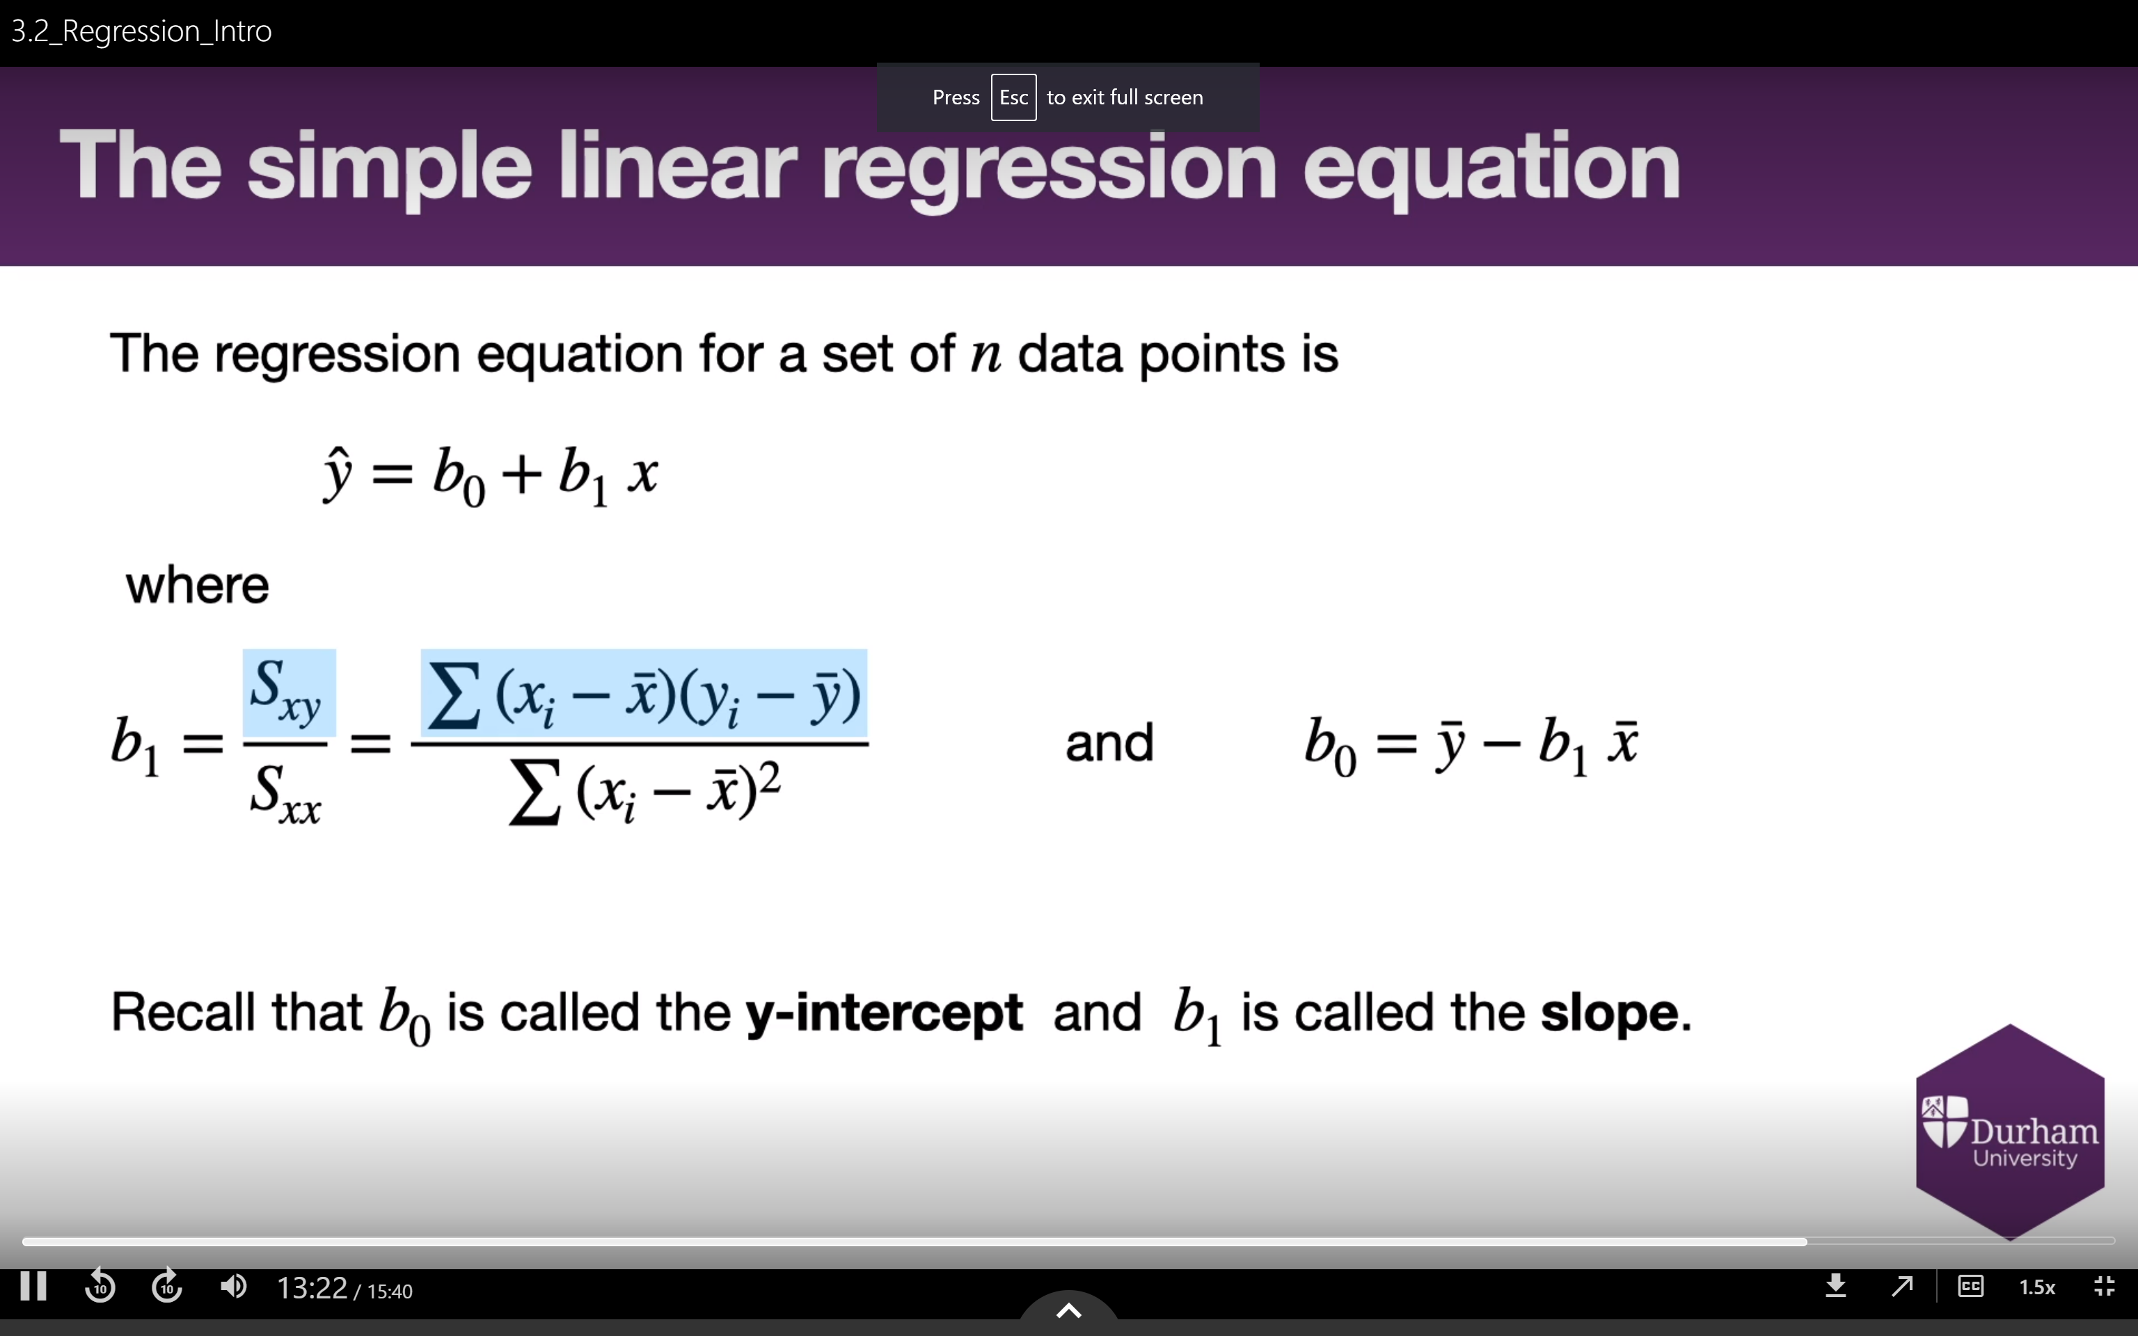

The formula for the line of best fit is now on screen – note that we’re defining the coordinate on the vertical axis as y hat, rather than y, to represent the fact that this line is giving us estimated values. I’m not going to go through why the equation has the form it does, though we will be coming back to the form it takes. What most matters from our perspective is that R can find this line for us with a single line of code, as you’ll see in this week’s workshop. We refer to this equation that gives us the regression line, rather unimaginatively, as the **regression equation.**

Let’s go back to the cars data. By use of the lm function in R, I can calculate that the regression line for this scatter diagram has the regression equation y hat = 3.932 times x minus 17.579. As we can see, this is a pretty good line in terms of approximating the relationship between how fast a car is going, and how long it takes to brake. Using the line to generate estimates is nice and simple. A car going at 5 miles per hour, for instance, has its stopping distance estimated at 2.08 feet.

One particularly nice feature of a regression line is that it always goes through the point x bar, y bar. That means our prediction for the sample mean value of x is always the sample mean value of y, which seems like a good idea – it would be odd if it were anything else, I think.

And there we go. Get your data, use R to generate the regression line, use that line to make predictions. Bosh.

(Slide)

I’ve decided to do this video backwards, though. Having shown you how to find a regression line to use in practice, I’m now going to talk about the theory that makes regression lines useful. Let’s cast our minds back to Weeks 3 and 4, when I talked about estimators and estimates. In everything we’ve done so far, we’ve always assumed there are true parameter values for a distribution, like the mean, or the standard deviation. Our job has always been to try and find statistical values that are as close to the true parameter as possible. If we assume data is coming from a normal distribution, we try to find good estimates for the mean and variance.

We’re actually doing a very similar thing here. We’ve made the assumption that there exists a linear relationship between x and y; an actual slope and y-intercept that truly represent this relationship between variables. The problem is, just like always, we can’t **actually find** those values. We can only approximate them.

In other words, these true values of the slope and the y-intercept are parameters. We use beta subscript one to denote the true slope, and beta subscript two to denote the true y-intercept. b subscript 1 is an estimator for beta subscript 1, and b subscript 0 is an estimator for beta subscript zero. We will talk later about the sampling distributions for b subscript 1 and b subscript 0, but it should hopefully at last make sense that shoes distributions exist – different samples of x and y values will lead to us drawing different lines of regression, so b 1 and b 0 are themselves random variables.

There’s one more thing we need to consider here. Even if we found the true values beta 1 and beta 0, we wouldn’t expect them to give us perfect predictions every time, any more than finding the true mean and true variance of a normal distribution would allow us to guess what each realisation from that normal distribution will be. We therefore express the true linear relationship as follows: each value of y is equal to beta one multiplied by the corresponding value of x, plus beta 0, **plus** another value epsilon, which we call the **error term**. We call this the regression model for the population.

We then also have a regression model for the sample, which replaces beta 1 and beta 0 with b 1 and b 0, respectively (sometimes we use beta hat 1 and beta hat 0 instead, to highlight that we are finding estimated values for beta 1 and beta 0). Instead of an error term, representing the difference between y and beta 1 times x plus beta 0, we have what we call a **residual term**, representing the difference between y and b 1 times x plus beta 0.

We will talk more about other forms of regression later in the term, but all of them take a similar form to this one: there is some true function we could run X through, and the output, plus an error term, would equal to Y. The tricky parts are that we can never find the true function, and if we don’t have a good idea of roughly how the function behaves, the error values can be very large and/or very hard to predict.

In summary, there are many circumstances in which two random variables, called the independent variable and the dependent variable, have a linear relationship. In such a circumstance, the least squares criterion gives us a way to judge how well a line of best fit approximates that relationship, in terms of how close vertically the line comes to each point. The line which minimises the least squares criterion is known as the regression line, with an equation known as the regression equation. This equation can be used to generate estimates of the dependent variable value from the value of the independent variable.

Next time on Ric’s Maths Corner, we’ll take a look at what we can conclude about a situation from the regression line. In particular, we’ll consider what the slope and y-intecept values actually represent, how to tell whether a regression line is too dependent on the location of a small number of points, and how to measure how much of the variance in our dependent variable is explained by the regression line we’ve drawn.

Fuck off

**Vid 6.3 – Regression Performance**

Greetings

In our last video, we took a look at how to take a scatter diagram, and draw the best line of best fit possible, for a definition of “best” we call the least squares criterion,

In that video, I talked about the underlying theory of what we call the **regression line**, and we saw how to use it to take a value from what we call the **predictor variable**, and use it to generate an estimated value of what we call the **response variable**.

In this video, we’re going to stick with the idea of what we can do with the regression line, and with the **regression equation** which defines it.

Let’s talk learning objectives, then. In this video, we will 1) explore the meaning of the slope and y-intercept of the regression line, 2) consider the limitations of the method in general and with regard to any given regression line in particular, and 3) consider how much of the way the response variable varies is actually being explained by the way the **predictor** variable varies, by introducing the **coefficient of determination**.

(Slide)

Let’s return to our running example of car stopping distances. In our last video, I gave you the regression equation of y hat = 3.932 times x minus 17.579 – remember, y hat is the estimated value of y we get for a value of x. What do the values of 3.932 and 17.579 actually represent in this context?

In this example, 3.932 is the gradient, the measurement of slope. Each time we add 1 to the value of x, we add 3.932 to the value of y bar. In the context of the example, then, the gradient tells us that for every additional 1 unit of speed in miles per hour, we predict an additional 3.932 units of stopping distance in feet. This is how we interpret the gradient in general, in fact – it tells us how much our prediction will increase (or decrease, if the gradient is negative) with an increase in one unit of the predictor variable.

Does the y-intercept have a similar interpretation? The answer is “sometimes”. By definition, the y-intercept is the value the line takes as it passes through the vertical axis. This is equivalent here to saying the y-intercept is the predicted value for the response variable when the value of the predictor variable is zero. In the car stopping distance example, our prediction for the stopping distance of a car going at zero miles per hour would be negative 17.579 feet.

Now, a prediction of negative 17.579 feet’s worth of stopping distance for a stationary car is clearly ridiculous. Should this worry us? Not at all. This The data set didn’t contain any stationary cars, for reasons I’m sure are obvious. The fact our model doesn’t work for values we never saw shouldn’t bother us at all. We just need to remember that point more generally.

This leads us on to the topic of **extrapolation**. In a statistical context, extrapolation is the act of using a model to make predictions using data that lies outside the range we used to generate the model. In general, this is a **very** bad idea, because you’re making an assumption that a relationship you’ve seen in a specific context will hold outside that context, and you have no evidence that’s true. When you draw a regression line, you should only ever use it to make predictions for predictor variable values which are between the minimum and maximum value of the predictor variable in the data.

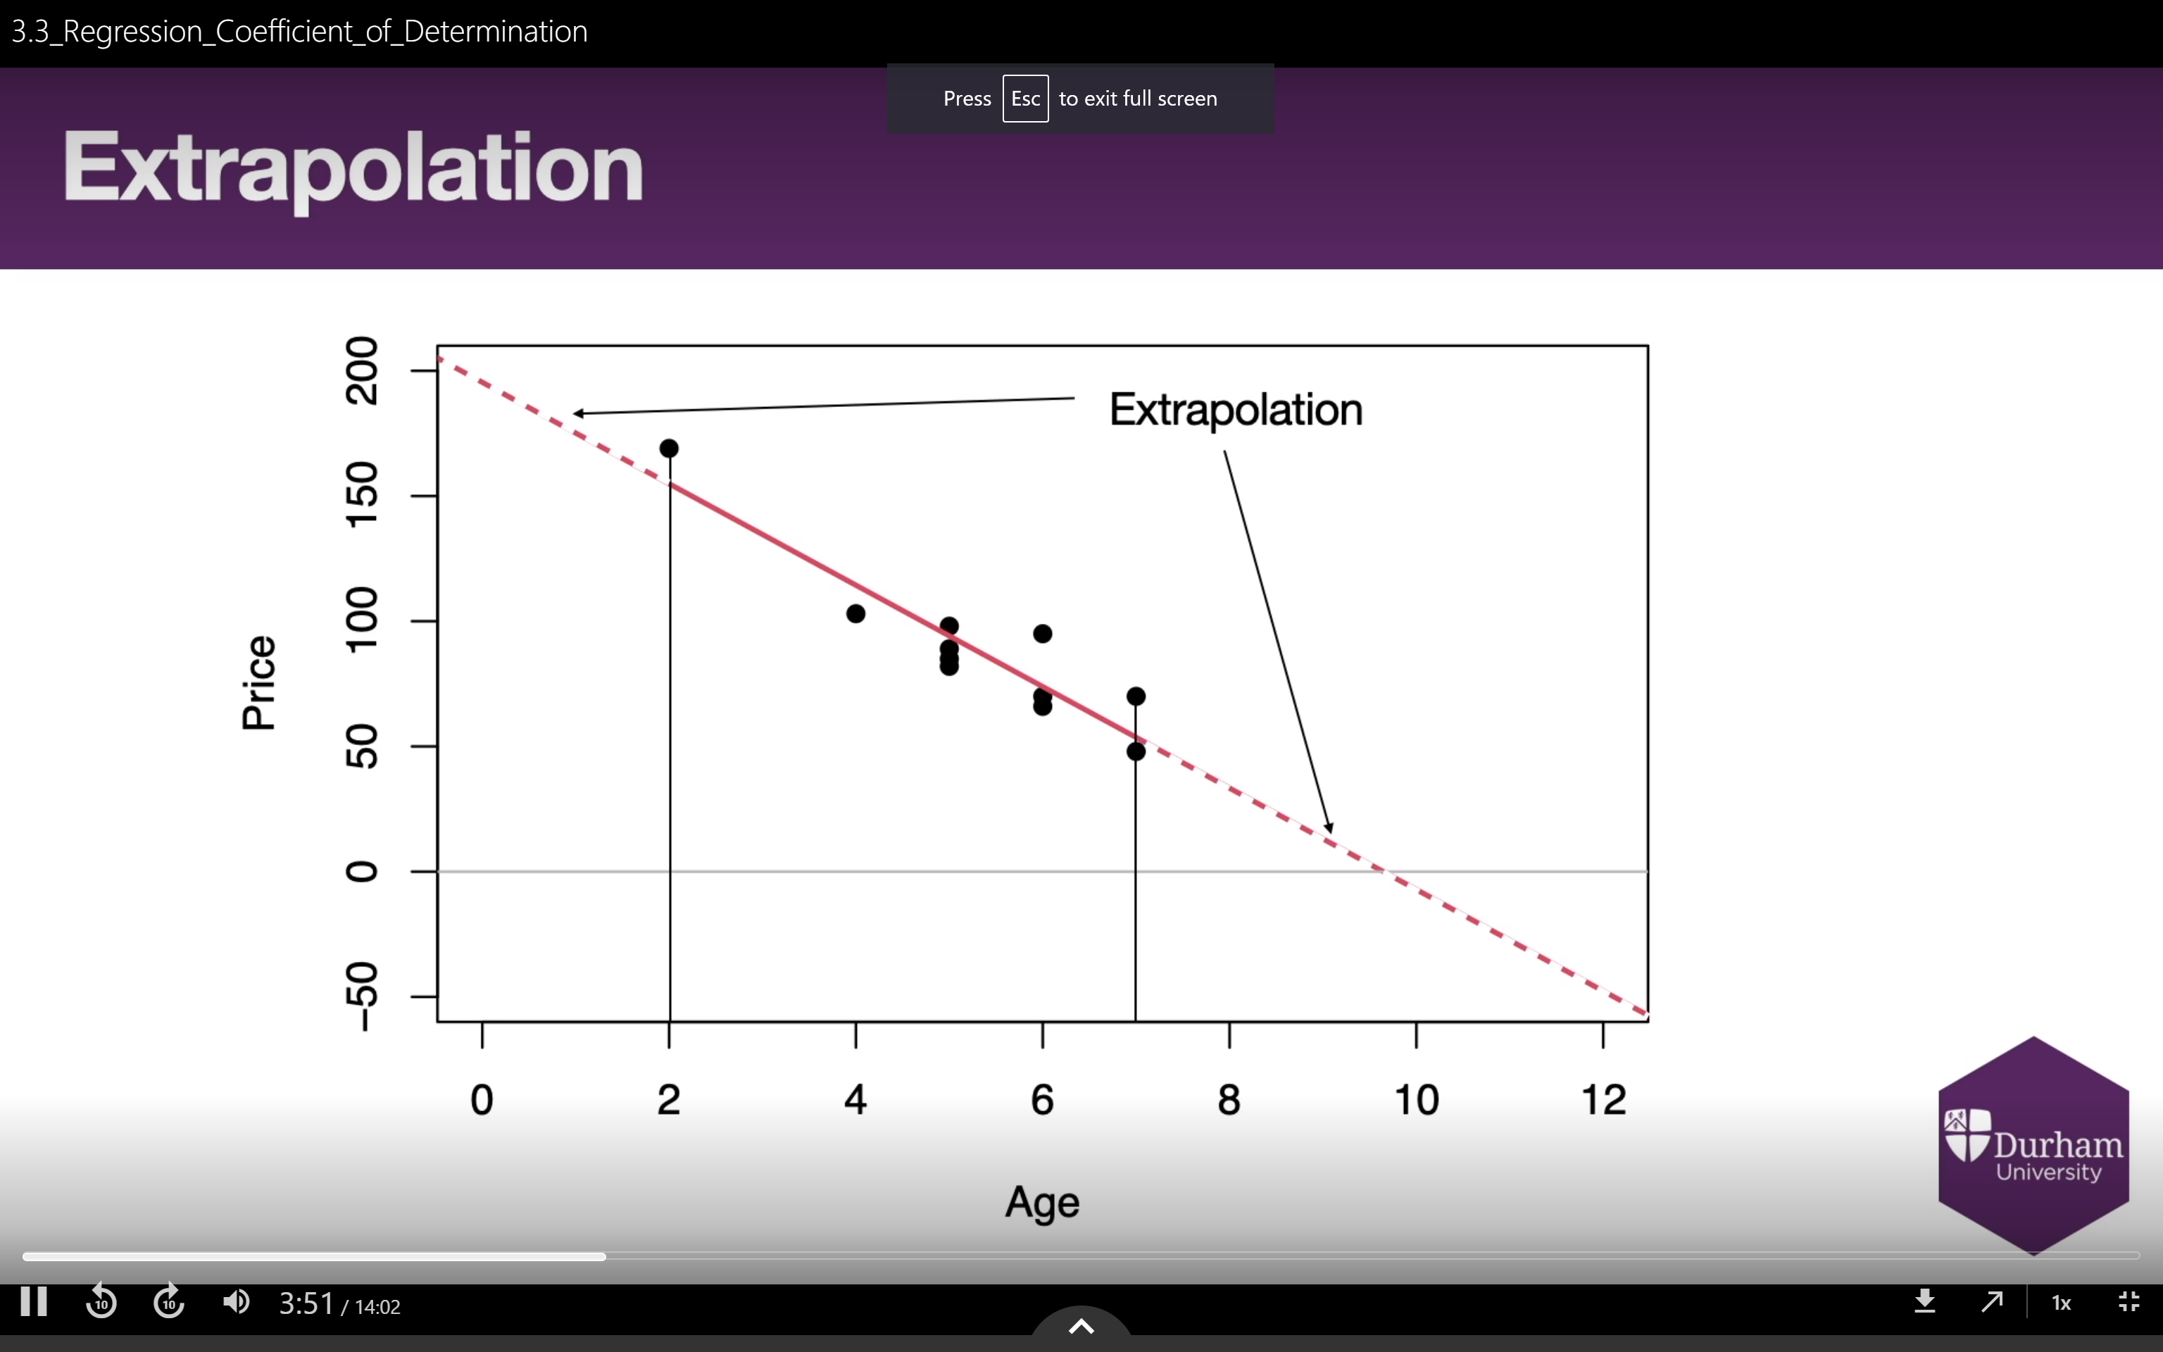

To return to the question of what the y-intercept represents, then, it **will** have a sensible interpretation when the interval of predictor variable values you’ve used to draw the regression line include zero.

(Slide)

Extrapolation is just one example of the limitations of linear regression. There are other issues we need to consider. We’ve looked at outliers in a few different contexts. In the context of linear regression, an outlier is a point that lies far away from the regression line. We need to consider what we do about outliers when using linear regression as a method. The answer to this depends on a concept known as **influence.**

We call a data point influential if removing it from the data set would cause the regression line to look very different. This isn’t a desirable property for any point to have, because you don’t want your model to be so dependent on just one value.

Outliers very often have high influence, and when they do,, we check them carefully to see if there is any way we can justify removing them from the data set. Is perhaps a measurement incorrect? Does the point represents values taken in a very different context to that of the others?

Let’s go through an example. Suppose we add a 51st point to the cars data set, representing a car with a speed value of 25mph, and a stopping distance of 1020 feet. Adding in this new point and recalculating the values for the regression equation shows us that the new line is very different to the old one. If the outlier isn’t removed, we’re going to be making rather different predictions than we would with the outlier gone, which is a big issue regarding accuracy.

In this case, removing the outlier seems obviously reasonable – a car going at 25mph is not going to take almost a third of a kilometre to come to a stop! An alternative to removing it would be to check with the original data source, to see if an explanation for the strange stopping distance value can be found. Perhaps the value has been accidentally been measured in inches, rather than feet. There are 12 inches in a foot, so if this is indeed the problem, the true stopping distance would be 85 feet, which would no longer be an outlier. The regression line will still change after adding the point (25, 85), but not to remotely the same extent.

There is no formal mathematical test to determine when you can remove an outlier, or even when you **should**, this is one of the situations in which a statistician must use their best judgment, informed by their prior experience. That said, we do have a measurement of influence known as **Cook’s distance**, which we’ll be taking a look at next week.

(Slide)

A question we’ve not yet talked about is how well our linear regression model fits the data we’ve used to create it. We know how to use correlation to judge how close the points are to being on a straight line, but we cannot generalise correlation to a case where there are multiple predictor variables, which limits its usefulness.

Instead, we use the **coefficient of determination**. I’ll define this value in a few minutes, but we have a bit of work to do first in order to set the definition up.

We saw in our last video that the regression line is thought of as the “best” line of best fit because it’s the line which minimises the sum of squares value. We can take this idea further. The aim of a regression line is to try to use changes in the predictor variable value to explain changes in the response variable value. What we’re interested in is how well that explanation works. Another way to say this is we’re trying to use the variation in x to explain the variation in y. Hopefully you remember how, back in Week 2, I defined variation in terms of the squared distance we expect any individual value of a variable to take from the mean value of that variable. This too relates to squared distances, just like the definition of the regression line.

Take a look at the diagram I’ve got on screen.

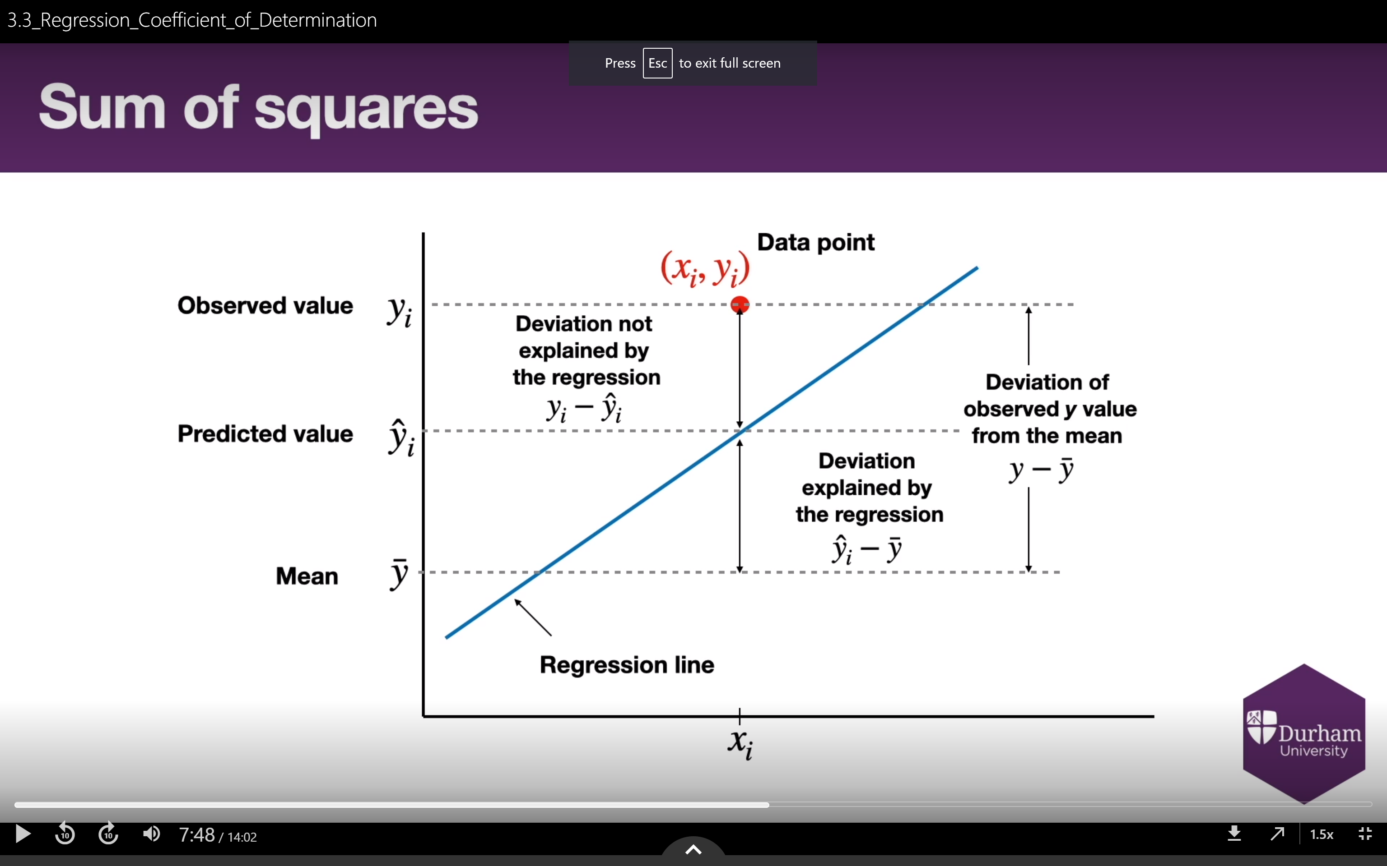

Here I am using the word “deviance” rather than “difference”, to bring us in line with common statistical terminology. The total deviance between an individual value of y and the mean value of y is y minus y bar. This deviance can be divided into two parts – y hat minus y bar, and y minus y hat. That first part represents the deviance we have successfully explained using the regression line. The second part, which as we saw in the last video is known as the residual, represents the deviance we have failed to explain.

I won’t go through this – you can give it a go for yourselves as an exercise if you’d like – but the useful property for us here is that if you the square the value for explained deviance, square the value for unexplained deviance, and add them together, you get the squared value of the overall deviance.

We call the sum of squared values of the deviance explained by our regression the **regression sum of square**s, or SSR. We call the sum of squared values of the unexplained deviance the error sum of squares, or SSE. These then sum together to give us the total sum of squares, or SST, which is equal to the sample variance multiplied by n over n-1. This is useful, because it means the value of SST is the same no matter which line of best fit we draw, only SSR and SSE will change. The value of SSE for the regression line will be the lowest we can get by drawing any line of best fit.

It’s very important to bear in mind that some people call the total sum of squares the residual sum of squares, which they shorted to RSS. So RSS is the same thing as SST, **not** the same things as SSR. This is unnecessarily confusing, and extremely annoying as a result – always be sure you understand which names are being given to which terms when looking at sum of squares values!

How does any of this help us? Well, the better the regression line fits the data, the smaller SSE will be, and the larger SSR will be – remember, these values sum to give SST, and SST is a value we get from the data itself. The smallest SSE can be is 0, which would mean the points all lie on a line anyway. The smallest SSR can be is zero, which represents drawing a horizontal line of best fit – this line would explain none of the variance of y in terms of the variance in x, because the line would give the same estimate of y no matter what value of x is used.

What we want, then, is a measurement for how well a regression line is working which takes its maximum value when SSE is zero, and takes its minimum value when SSR is zero. The coefficient of determinism is what we use to do this. We denote this by capital R squared, and it is defined as being the value of SSR divided by SST. When SSR is zero, so is R squared. When SSE is zero, SSR and SST are equal, making R squared equal to 1. The closer R squared is to 1, the better the regression line is doing at explaining the variation in the response variable. As an extremely rough rule of thumb, you want R squared to be at least 0.7 before you claim the regression model is a good explanation for the underlying relationship between your variables.

Why do we use the notation R squared? We often use a lower case r to represent the correlation we observe in a sample, and for the case where we’re using simple linear regression, R squared is in fact the square of the correlation lower case r. As mentioned previously, though, correlation cannot be expressed when there are multiple predictor variables – or at least, it can’t be expressed using a single number. In those situations, R squared is a much more helpful measurement.

One last point to make about the coefficient of determination – it can sometimes lead us astray. We’ll be talking a lot more about this soon, but it is **always** possible to increase the value of R squared by just adding more predictor variables. It might not increase by much, if the additional predictor variables have very little or no relationship with the response variable, but they will always appear to provide at least a little additional information, which the regression model will make use of.

This is a problem, because we don’t want to be throwing more and more predictors into our models. For a start, doing this makes prediction tougher to actually get done, because you need to find the values of more variables to feed into your model. Further, any predictor variable you put in which doesn’t actually have a useful relationship with the response variable will make the model more likely to be wrong. The phenomenon where it appears a model is getting better while we’re actually making it worse is referred to as **overfitting**, and we’ll be coming back to it very soon.

For now, though, the point I’m making is R squared cannot recognise when you’ve put in too many predictor variables. To deal with this, we have the extremely unimaginatively titled “adjusted R squared”, a value of R squared which is – you’ve guessed it – adjusted, to take account of how many predictors have been included. For a model containing k predictor variables, the value of adjusted R^2 is equal to 1 subtract 1 subtract R squared multiplied by n-1 over n – k – 1. Now the fact that R squared itself keeps getting larger as we add in predictor variable is compensated for by the fact n-k-1 is also getting bigger. Note that unlike R squared itself, the adjusted R squared can take a value less than zero, although its maximum value – representing a perfect fit – remains 1.

Time to sum up, I think. When we draw a regression line, we can always interpret the slope as being how much of a change in the response variable we expect following an increase of one unit in the predictor variable. Outliers can have great influence on a regression line, making the line look quite different to how it would look with those values removed, so such points should be carefully considered to see if they can be removed. Finally, we can calculate the coefficient of determination to judge how well a regression line fits the data.

Fuck off.

**Video 6.4 – Regression Diagnostics**

